1) DCHP troubleshoot:

Ans: <https://www.petri.com/troubleshoot-dhcp-problem>

DNS in details

<https://www.cloudflare.com/learning/dns/what-is-dns/>

DNS Record types

<https://ns1.com/resources/what-is-dns>

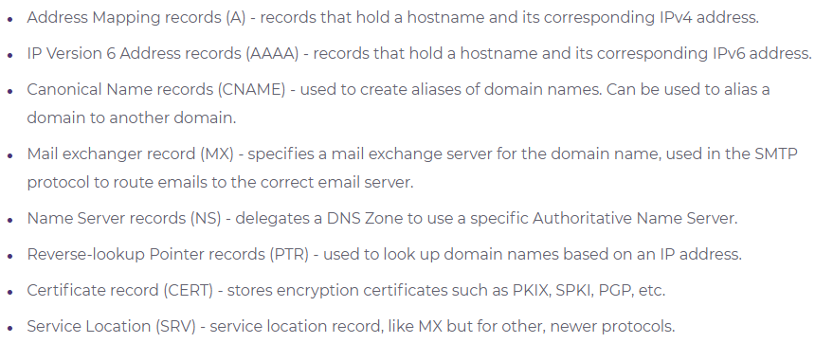

What is proxy

<https://www.varonis.com/blog/what-is-a-proxy-server/>

#how to check invalid IP:

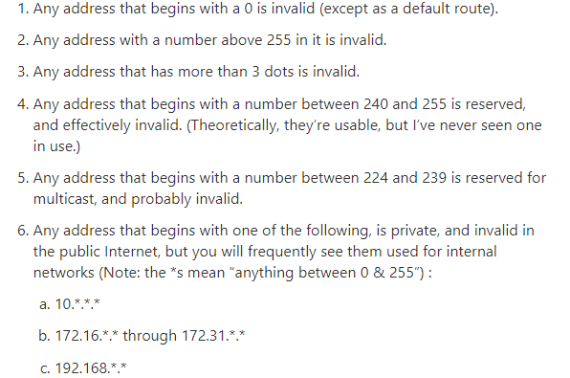

Apipa

# Linux bootup process

<https://www.thegeekstuff.com/2011/02/linux-boot-process/>

ping

<https://blog.paessler.com/how-to-use-ping-for-troubleshooting>

Types of firewall

1. Packet filtering firewall
2. Circuit level firewall
3. Stateful firewall
4. Proxy firewall
5. Next gen firewall provides deep packet inspection, Intrusion prevention system

(Dos attacks, DDos attacks)

1. Hardware fallwall Cisco Device
2. Software firewall Mcfee Nortan
3. Cloud firewall Amazon Web Application firewall

<https://www.compuquip.com/blog/the-different-types-of-firewall-architectures>

TCP in detail

<https://www.geeksforgeeks.org/services-and-segment-structure-in-tcp/>

TCP 4 way handshake

<https://www.geeksforgeeks.org/tcp-connection-termination/>

TCP flow control and receiver window and sliding window

<https://www.brianstorti.com/tcp-flow-control/>

<https://www.studytonight.com/post/flow-control-stop-wait-and-stop-wait-arq-protocol>

flow control stop and wait

and flow control stop and wait ARQ- Automatic repeat request